Little Boy – Nektar -Pt.2
(note on the original studio recording there are two guitars picking and I have combined them both to one guitar which is a lot harder to play)
(This has been worked out by ear so it is not as exactly how Roye plays it and is only my own interpretation of it. Chords and positions may be different. And please excuse some of the bum notes as I have a stuffed finger still, which makes doing this extremely difficult for me- (lots of pain and frustration) You will have to wait on Roye to do an exact tab of this.

Next chord is D#m7 on the 6th fret
The picking is the same as for the B but with and added 7th and not a sixth and the 7th is not dropped at the end
The sequence is T, 2, 1, 3, 2, 1, 3, 2
Another New chord which is still in fact a D#m7th, use your little finger to produce this chord from D#m7
You pluck both T & 3 together at the same time x 2 times.

Note the T on the second chord is on the 4th string and not the bass note of the chord.

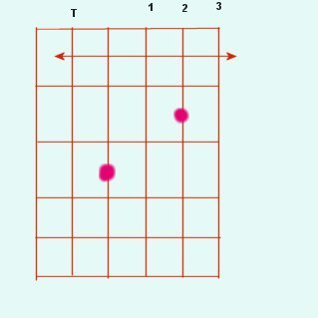
D#m7 – 6th fret D#m7/add7th
3
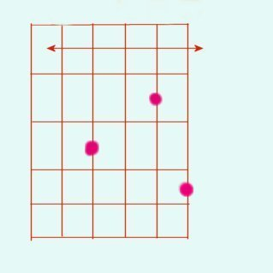
T

It should sound like this
With both parts it sounds like this

Next is a tricky bit, even though the chord sequence for the verse & intro are B D#m7 C#m7 F# The F# is not played as will be shown.
1. The picking sequence is T, 2, 1, 3,
2. With the added note, (use your little finger again).
The picking sequence is T, 1, 2, T, 1, 3, T, 1, 2,
C#m7 – 4th fret C#m7 with added note – 4th fret
T
2
3
1
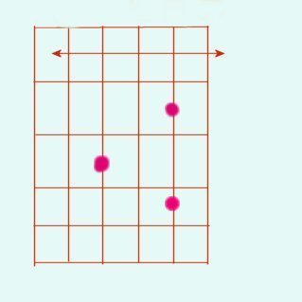

Next drop the added note with a pull off from the added note on C#m7 but also lift your finger off the string on the 2nd string and the bar to ring the open B string. (a tricky bit) Roye may place this elsewhere on the neck then I have shown.
C#m7 note dropped on 2nd string
2

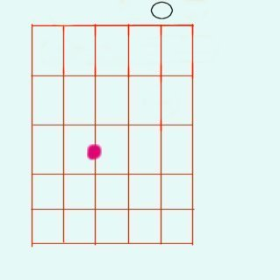

Next bit of picking on the same chord again (C#m7 with the dropped note)

C#m7 note dropped on 2nd string C#m7 with added note – 4th fret
2
T
1
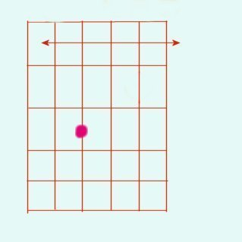
3
2
1
T

The sequence is 3, T, 1, T, then the chord with the added note again.
(Don’t use the finger on note with the arrow.)
Sequence is 2, 1, T.
Then the chord with the dropped note as above, leave the bar in place this time.
Next bit uses a “hammer on” (do you know what a hammer on is?)
The notes are B open string, hammered to C# on the 2nd fret.
Then another B open.
Then a E-open on the first string. (see chord box below)
So this sequence is
B-C#-B-E (make the notes ring clear)

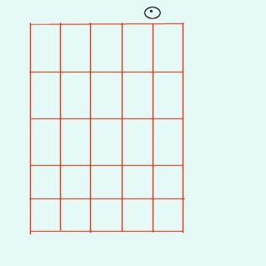
B open string C# on the 2nd fret

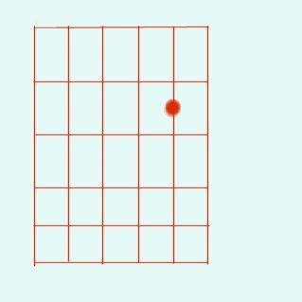

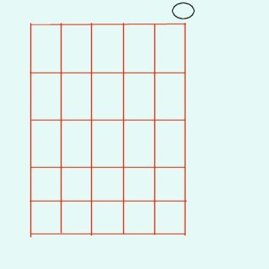
E open string

And the whole verse sequence should sound like this

Ok so far…..
Now I will add the lyrics for the verse and once you know how to play it well enough have a go at trying to sing while you are picking this…….:)
It is not easy, in fact it is extremely hard……………….

Intro x1

Verse 1.

Little boy covered in makeup, what has this world done to him.
You think I’m only joking but I tell you we’re not getting through.

Verse 2.

Don’t mind growing older, what has this life done to him.
You think I’m only joking but I tell you we’re not getting through.

The actual format of the song is

Intro x 1
Verse 1.
Chorus.1
Verse 2.
Chorus.2
Lead Break
Chorus.2 x 2
For the chorus see Pt.3

